Wallet Engineering
(highlights and important notes)

Contents
OpenZeppelin cryptography 3
ECDSA.recover() 3
EIP-712 4
Specification 5
Definition of hashStruct 5
Definition of encodeType 6
Definition of encodeData 6
Definition of domainSeparator 6
Why EIP-712 introduces a domain separator 8
OpenZeppelin EIP-712 8
What OpenZeppelin's EIP712 implements 8
abi.encode() 10

OpenZeppelin cryptography

ECDSA.recover()
A normal signature is roughly:
signature = (r, s)
Ethereum adds another tiny value:
signature = (r, s, v)
That v value gives enough extra information for the ECDSA math to reconstruct the public key from:
the message hash
(r, s, v)
So OpenZeppelin can do:
address signer = ECDSA.recover(messageHash, signature);
and get the Ethereum address of the public key that produced the signature. OpenZeppelin explicitly describes recover as returning “the address that signed a hashed message.”
Then you usually verify it yourself:
address signer = ECDSA.recover(hash, signature);

require(signer == expectedAddress, "wrong signer");
So conceptually:
private key
↓ sign
message hash ─────→ signature (r,s,v)
↓
recover(hash, signature)
↓
public key
↓
ETH address
You don't provide the public key because recover() derives it from the signature.

One important distinction: recover() by itself doesn't know who you expected to sign. It just tells you who did sign. You still compare the recovered address against an expected address.

EIP-712
Signing data is a solved problem if all we care about are bytestrings. Unfortunately, in the real world we care about complex meaningful messages. Hashing structured data is non-trivial and errors result in loss of the security properties of the system.
As such, the adage “don’t roll your own crypto” applies. Instead, a peer-reviewed well-tested standard method needs to be used. This EIP aims to be that standard.
This EIP aims to improve the usability of off-chain message signing for use on-chain. We are seeing growing adoption of off-chain message signing as it saves gas and reduces the number of transactions on the blockchain. Currently signed messages are an opaque hex string displayed to the user with little context about the items that make up the message.
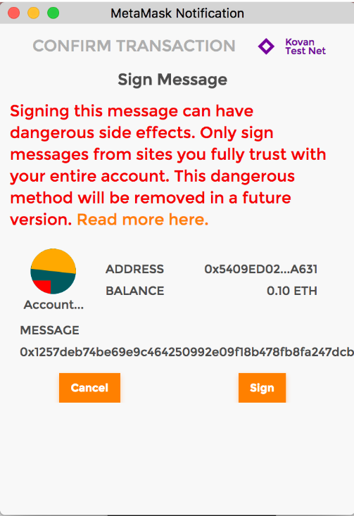
Here we outline a scheme to encode data along with its structure which allows it to be displayed to the user for verification when signing. Below is an example of what a user could be shown when signing a message according to the present proposal.
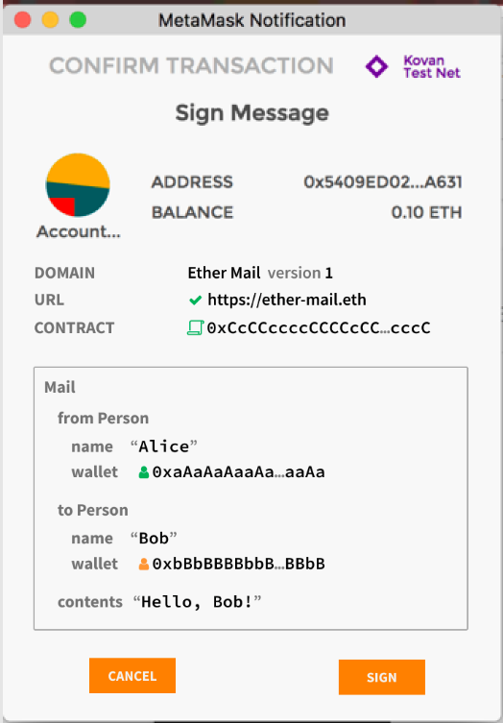

Specification
The set of signable messages is extended from transactions and bytestrings 𝕋 ∪ 𝔹⁸ⁿ to also include structured data 𝕊. The new set of signable messages is thus 𝕋 ∪ 𝔹⁸ⁿ ∪ 𝕊. They are encoded to bytestrings suitable for hashing and signing.

Definition of hashStruct
The hashStruct function is defined as
hashStruct(s : 𝕊) = keccak256(typeHash ‖ encodeData(s)) where typeHash = keccak256(encodeType(typeOf(s)))
Note: The typeHash is a constant for a given struct type and does not need to be runtime computed.

Definition of encodeType
The type of a struct is encoded as name ‖ "(" ‖ member₁ ‖ "," ‖ member₂ ‖ "," ‖ … ‖ memberₙ ")" where each member is written as type ‖ " " ‖ name. For example, the above Mail struct is encoded as:
Mail(address from,address to,string contents).
If the struct type references other struct types (and these in turn reference even more struct types), then the set of referenced struct types is collected, sorted by name and appended to the encoding. An example encoding is:
Transaction(Person from,Person to,Asset tx)Asset(address token,uint256 amount)Person(address wallet,string name).

Definition of encodeData
The encoding of a struct instance is enc(value₁) ‖ enc(value₂) ‖ … ‖ enc(valueₙ), i.e. the concatenation of the encoded member values in the order that they appear in the type. Each encoded member value is exactly 32-byte long.
The atomic values are encoded as follows: Boolean false and true are encoded as uint256 values 0 and 1 respectively. Addresses are encoded as uint160. Integer values are sign-extended to 256-bit and encoded in big endian order. bytes1 to bytes31 are arrays with a beginning (index 0) and an end (index length - 1), they are zero-padded at the end to bytes32 and encoded in beginning to end order. This corresponds to their encoding in ABI v1 and v2.
The dynamic values bytes and string are encoded as a keccak256 hash of their contents.
The array values are encoded as the keccak256 hash of the concatenated encodeData of their contents (i.e. the encoding of SomeType[5] is identical to that of a struct containing five members of type SomeType).
The struct values are encoded recursively as hashStruct(value). This is undefined for cyclical data.
Basically, we just put all the members hashes together. Wow! So complicated and original!

Definition of domainSeparator
domainSeparator = hashStruct(eip712Domain)
where the type of eip712Domain is a struct named EIP712Domain with one or more of the below fields. Protocol designers only need to include the fields that make sense for their signing domain. Unused fields are left out of the struct type.
- string name the user readable name of signing domain, i.e. the name of the DApp or the protocol.
- string version the current major version of the signing domain. Signatures from different versions are not compatible.
- uint256 chainId the EIP-155 chain id. The user-agent should refuse signing if it does not match the currently active chain.
- address verifyingContract the address of the contract that will verify the signature. The user-agent may do contract specific phishing prevention.
- bytes32 salt a disambiguating salt for the protocol. This can be used as a domain separator of last resort.
For example, imagine you sign the message “Approve Bob to spend 100 tokens.” Without context, another contract using the exact same message format might potentially interpret that same signature. So EIP-712 effectively signs something closer to: “Approve Bob for 100 tokens, for MyToken v1, on Ethereum chain 1, specifically for contract 0xABC....” The domain separator is the hashed version of that bolded where/which-system information. When the final signature hash is created, EIP-712 combines domainSeparator with the hash of the actual message. That means changing the contract address, chain, protocol name, or version can produce a different thing to sign, helping prevent a signature intended for one context from being reused in another.
Final hash could be something like:
keccak256( 0x1901 || domainSeparator || hashStruct(message) )

Why EIP-712 introduces a domain separator
A domain separator is not required because the data is a struct. Domain separation is a general cryptographic idea used to prevent the same hash/signature from being valid in the wrong context. Since it’s a struct, it is introduced here.
A normal value like uint256(100) can be hashed with:
keccak256(abi.encode(100))
and no domain is needed if we only care about hashing the value itself.
But when signing data, context matters. The same signed value or message could otherwise be reused by another contract or application with a different meaning.
EIP-712 therefore signs roughly:
keccak256(0x1901 || domainSeparator || hashStruct(message))
- hashStruct(message) = what is being signed
- domainSeparator = where/in which context it is valid
- The domain commonly includes name, version, chainId, and verifyingContract.
The domain is applied once to the final struct hash because that struct hash already commits to all fields inside the message.
Also:
- typeHash separates different message types, e.g. Permit(...) vs Order(...).
- domainSeparator separates different apps/contracts/chains/versions.
So EIP-712 did not invent domain separation for structs; it standardized domain separation for typed signed messages.

OpenZeppelin EIP-712

What OpenZeppelin's EIP712 implements
OpenZeppelin implements the parts of EIP-712 that are generic for every protocol:
- _domainSeparatorV4() → creates the EIP-712 domain separator.
- _hashTypedDataV4(structHash) → combines the domain separator and your struct hash to produce the final digest used for ECDSA signing/recovery.
Conceptually:
your struct -> structHash we implement
then:
structHash + domainSeparator -> final digest OpenZeppelin implements
OpenZeppelin does not generically hash arbitrary Solidity structs because Solidity cannot inspect an unknown struct at runtime. There is no function like:
hashAnything(anyStruct)
that can discover:
- the struct name
- field names
- field types
- nested structs
- arrays
- the EIP-712 type definition
but EIP-712 must hash them differently because their type and field names are different. abi.encode(address, uint256) alone does not preserve that information.
A generic recursive encoder would therefore need the schema/types passed separately and would effectively implement its own runtime type system/parser inside Solidity. This is possible in theory, but complex and gas-expensive.
Solidity doesn't have that kind of runtime reflection/generic type system. OpenZeppelin itself points out elsewhere that Solidity doesn't support generic types.
Imagine wanting this:
function hashAnything(??? someStruct)
returns (bytes32)
What type goes where ??? is?
Since a contract already knows its structs at compile time, it is much simpler and cheaper to write the specific encoding:
keccak256(abi.encode(PERMIT_TYPEHASH, owner, spender, value))
and then pass that structHash to OpenZeppelin's _hashTypedDataV4().

abi.encode()
abi.encode() takes Solidity values and converts them into a standardized bytes representation according to Ethereum’s ABI rules. For example, abi.encode(address, uint256) turns those values into bytes in a predictable format so they can be hashed, stored, or passed around. In EIP-712, you often do keccak256(abi.encode(TYPEHASH, field1, field2, ...)): abi.encode() first packs the typed values into canonical bytes, then keccak256 hashes those bytes.

